Pre-Campaign | Management letter of support
Have a member of your executive team send out this announcement 1-2 weeks before your campaign kickoff.

Subject Line: Show your local love with our United Way campaign
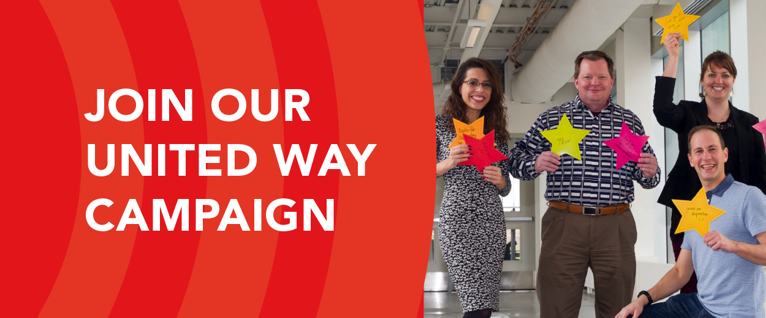
Dear «Name»,
We’re gearing up to take action and give back to our community with «Company»’s 2020 United Way campaign, running from «date» to «date»! This year, we’re asking you to show your local love and create ripples of positive impact in your community.
United Way of Calgary and Area brings people together to solve complex social issues and improve local lives. United Way shares our corporate values, believing everyone should be afforded equitable opportunities to reach their full potential, kids deserve the support they need to get a great start in life, and strong communities are vital to a great city. Last year, United Way helped 179,162 individuals across Calgary and the surrounding area build better lives. With your support through our campaign, United Way can help even more people access the opportunities they need to thrive—in turn strengthening our community.
I personally support United Way because «X». I encourage you to participate in our campaign by attending events, volunteering, and making a financial contribution.
This year, our company goal is to have «X» per cent participation and raise «$X». For every dollar that you donate, «Company» will match it with «$X», helping your donation create greater community impact. Right now, local philanthropists are also matching donations of $1,200 and over made to United Way, so your donation can be «tripled» during our campaign. All donations raised through our campaign will stay local.

[continued on next page]
Our campaign will kick off on «Date and Time» at «Zoom link/location». I look forward to seeing you there! You will receive more campaign details from our Employee Campaign Coordinator <<name>> prior to our kickoff. If you have any questions regarding the campaign, please reach out to <<name>> or visit <<company’s online engagement/intranet site>>.
Thank you for uniting to show your local love and improving lives across your community. I look forward to a fun-filled, impactful United Way campaign!
United, we truly make the biggest difference.
Sincerely,
«Executive Signature»

Pre-Campaign | Getting the word out
Send this email to all staff one week before your campaign kickoff to alert them of upcoming events.

Subject line: Upcoming events for our United Way campaign
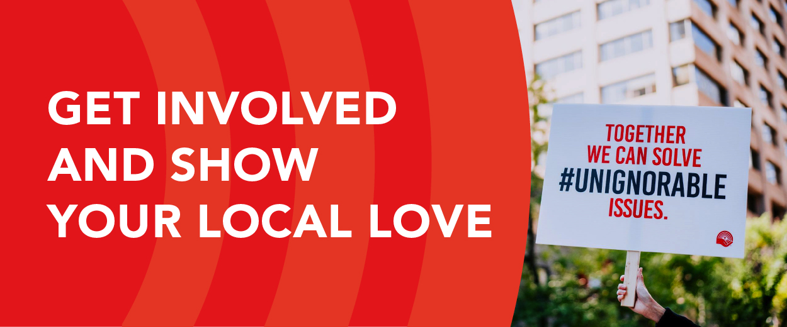
Dear «Name»,
On «date», our company will be kicking off our United Way of Calgary and Area campaign, and we would like to invite you to join us to show your local love!
Our involvement in this city-wide campaign is integral to creating lasting social change as we look to overcome poverty, help kids succeed, and build strong communities.
Our United Way – Show Your Local Love campaign will run from «date» to «date» and will feature plenty of activities–check out our calendar below! You can get involved by attending educational sessions, volunteering, participating in special events and contests, and by making a personal donation.
«Calendar event listing—include dates donations must be in to take advantage of your corporate match»
Please join us to learn more about United Way’s work and our upcoming campaign. We will meet to kick off on «date» at «time» in «Zoom link/room». Please RSVP by registering online at «registration link/name/email address».
Thanks and we look forward to seeing you there! United, we make the biggest difference.
Sincerely,
Your United Way campaign committee:
«Names»

Campaign Week | Morning of your kickoff
Have a member of the executive team send this email to all staff to remind them of your campaign kickoff.

Subject line: Today is the day!
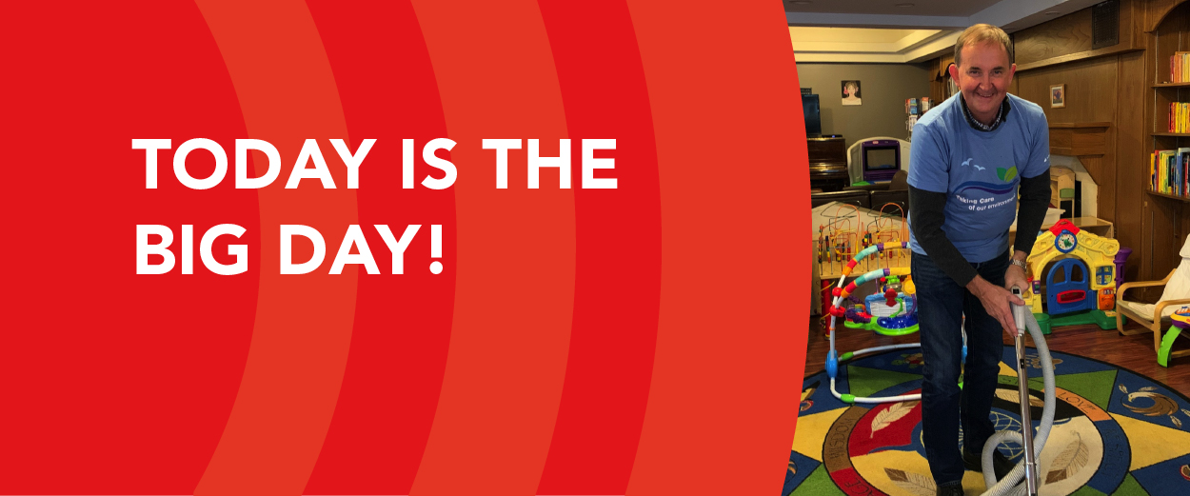
Good morning «Name»,
Today is the day «Company» kicks off our 2020 United Way campaign.
United Way of Calgary and Area brings together donors, corporations, agencies, and government to solve complex social issues and improve the lives of more than 150,000 people every year.
Join us today at «time» at «Zoom link» for our kickoff celebration to learn about United Way’s work and discover the many ways you can get involved.
This year, our company goal is to have «X» per cent participation and raise «$X». «Company» will also match donations made with «$X», helping your donation create greater community impact. Local philanthropists are also matching donations of $1,200 and over made to United Way right now, so your donation can be «tripled» during our campaign.
Together, we can show our local love and create lasting social change as we help people overcome poverty, help kids succeed, and build strong communities. United, we truly make the biggest difference.
I look forward to seeing you there!
Sincerely,
«Executive Signature»
Campaign Week | Fast Facts
Use these quick stats in daily emails, or to post on your intranet/social media sites. Visit calgaryunitedway.org/toolkit for visual versions of these stats.

In 2019, 179,162 local people were helped thanks to gifts from donors like you.

POVERTY | THE NEED
- COVID-19 has made it more difficult for people to access basic needs like food, shelter, and personal
hygiene items.
- More than 100,000 Calgarians live without enough money for food, shelter, and other basic needs.
POVERTY | Your support
- Supporting United Way ensures local people can meet their basic needs, stabilize their income, and access meaningful employment opportunities.

KIDS | THE NEED
- 1 in 4 kids in Calgary are not developmentally ready for kindergarten.
- In Canada, only 1 in 5 kids who need mental health services receive them. And 70% of adults with mental illness indicate their symptoms first emerged during childhood and adolescence.
KIDS | Your support
- Your donation to United Way helps kids reach developmental milestones, access mental health supports, finish high school, and build successful lives—from early childhood to young adulthood.

COMMUNITIES | THE NEED
- COVID-19 has added increased mental health stressors for many people, with job loss, social isolation, and access to basic needs—many of which people are experiencing for the first time.
- 1 in 3 Calgarians don’t feel like they belong in their community.
COMMUNITIES | Your support
- United Way creates a foundation for strong communities by investing in services and supports that strengthen and connect all residents, enabling thriving, inclusive, and vibrant neighbourhoods where everyone feels they belong.

Campaign Close-Out | Thank you email
Send this email after campaign week to celebrate your successes and thank employees.
Subject line: We did it! Together, we are improving lives!
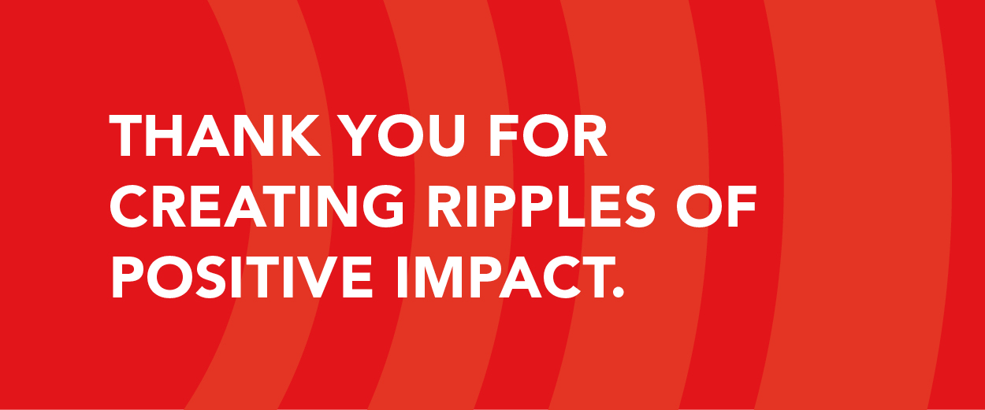
Dear «Name»,
Thank you to everyone who came together to show your local love and create ripples of positive impact in our community! United, we are making a difference—as a group, we raised an amazing «$X» during our United Way campaign and reached <<X>> per cent participation level. In addition, «X» per cent of employees gave their time and talents to this campaign. We are so proud of the caring community within our organization and commitment to helping others in need.
Your generous donations will support more than 150,000 people in our city. Because of you, individuals and families across Calgary and the surrounding area will be able to access the support and opportunities they need to thrive.
A special thanks to our 2020 volunteers for their time and efforts:
«Names and roles»
We hope you had fun with this year’s campaign and enjoyed the opportunity to learn more about how our efforts are contributing to a resilient and caring community where everyone thrives.
On behalf of «Company», United Way of Calgary and Area, and your peers in the community whose lives continue to be positively impacted by your generosity—thank you for showing your local love!
Sincerely,
Your United Way campaign committee:
«Names»

